|  |  |
| --- | --- |
| Date | 2 Nov 2022 |
| Team ID | PNT2022TMID53527 |
| Project Name | Smart Fashion Recommender Application |
| Team members | V.M.SUNILSUDHARSHAN  V.RAMESH ARAVIND  SOMASUNDARAM  S.YOGESH |
|  |  |

Sendgrid Open Page:



Sendgrid login Page:

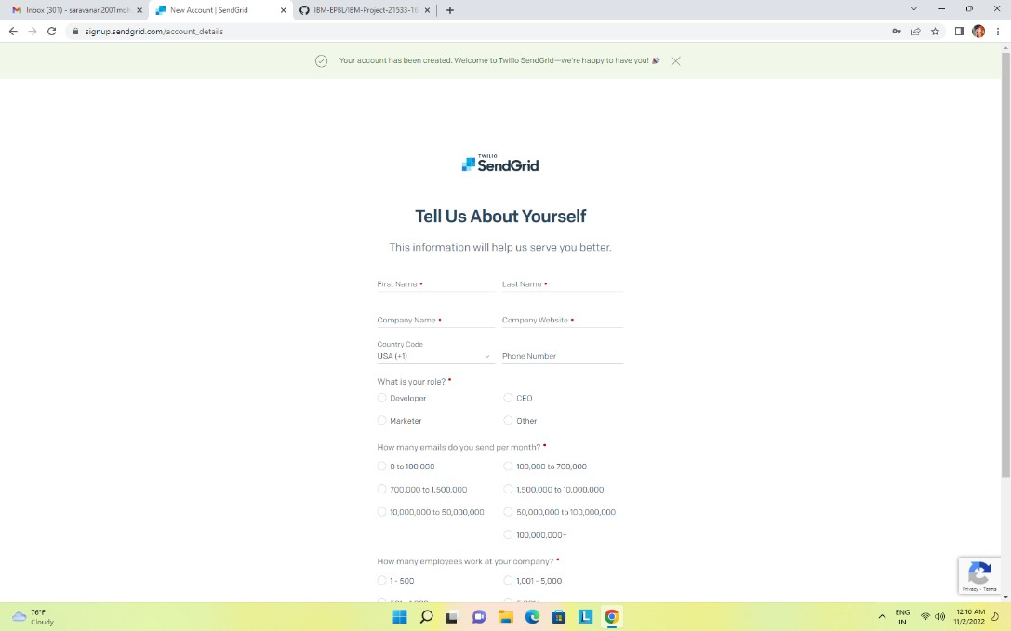

Sendgrid successfully created:

